**SoftUni OOP Game Contest**

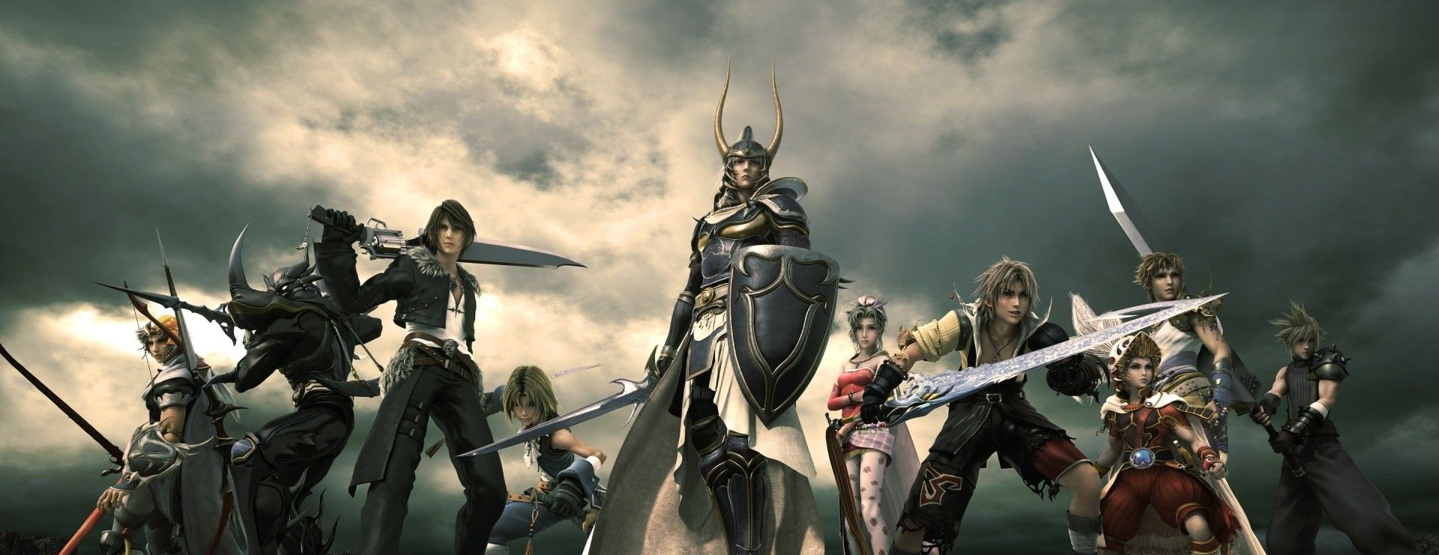

SoftUni is organizing a contest for the best **role playing game** from the OOP teamwork projects. The winning teams will receive a **grand prize!**

The game should be: